**Static Routing:**

Static routing is a form of routing that occurs when a router uses a manually-configured routing entry, rather than information from dynamic routing traffic.

Static Routing is also known as non-adaptive routing which doesn’t change the routing table unless the network administrator changes or modifies them manually. Static routing does not use complex routing algorithms and It provides higher or more security than dynamic routing.

**Network Design:**

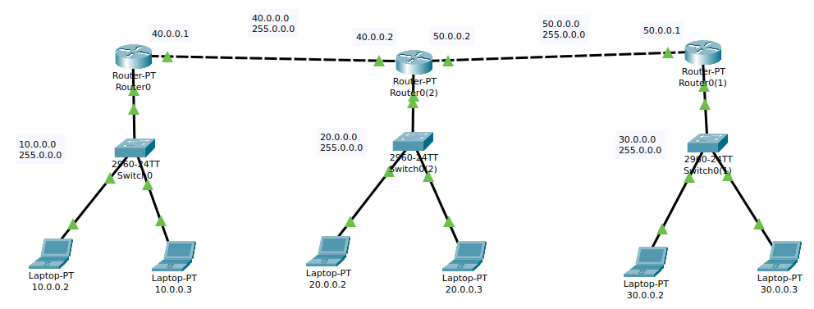

**Configuration Step:**

1. Assign IP addresses to all the connected PC’s respected to their network as the Network Design shows
2. Go to the router’s command-line interface (CLI).
3. Configure router with IP address and Subnet mask.
4. After configuring all of the devices we need to assign the routes to the routers.

**PC IP configuration:**

|  |  |  |  |
| --- | --- | --- | --- |
| Device | IP | Subnet Mask | Default gateway |
| Laptop 1 | 10.0.0.2 | 255.0.0.0 | 10.0.0.1 |
| Laptop 2 | 10.0.0.3 | 255.0.0.0 | 10.0.0.1 |
| Laptop 3 | 20.0.0.2 | 255.0.0.0 | 20.0.0.1 |
| Laptop 4 | 20.0.0.3 | 255.0.0.0 | 20.0.0.1 |
| Laptop 5 | 30.0.0.2 | 255.0.0.0 | 30.0.0.1 |
| Laptop 6 | 30.0.0.3 | 255.0.0.0 | 30.0.0.1 |

**Router Configuration Command:**

**Router 1**

en

conf t

int fa0/0

ip address 10.0.0.1 255.0.0.0

no shut

exit

int fa1/0

ip address 40.0.0.1 255.0.0.0

no shut

exit

ip route 20.0.0.0 255.0.0.0 40.0.0.2

ip route 30.0.0.0 255.0.0.0 40.0.0.2

exit

**Router 2**

en

conf t

int fa0/0

ip address 20.0.0.1 255.0.0.0

no shut

exit

int fa1/0

ip address 40.0.0.2 255.0.0.0

no shut

int fa2/0

ip address 50.0.0.2 255.0.0.0

no shut

exit

ip route 10.0.0.0 255.0.0.0 40.0.0.1

ip route 30.0.0.0 255.0.0.0 50.0.0.1

exit

**Router 3**

en

conf t

int fa0/0

ip address 30.0.0.1 255.0.0.0

no shut

exit

int fa1/0

ip address 50.0.0.1 255.0.0.0

no shut

exit

ip route 10.0.0.0 255.0.0.0 50.0.0.2

ip route 20.0.0.0 255.0.0.0 50.0.0.2

exit

**Output:**

